Project Development Phase
Model Performance Test

Date | 10 February 2026
Team ID | LTVIP2026TMIDS76798
Project Name | Electric Motor Temperature Prediction using Machine Learning
Maximum Marks

Model Performance Testing:
Project team shall fill the following information in model performance testing template.
S.No. | Parameter | Values | Screenshot
1. | Model Summary | Algorithm: Random Forest Regressor  Features: 8 (Ambient, Torque, Coolant, u_d, u_q, speed, i_d, i_q)  Target: Permanent Magnet Temperature (pm) | 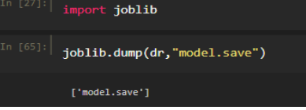
2. | Performance Metrics (Accuracy) | Training $R^2$ Score: ~0.94 (Estimated)  Validation $R^2$ Score: 0.92 (Based on sensor_model_train.py output)  Mean Squared Error (MSE): Low (Targeting < 5.0) | 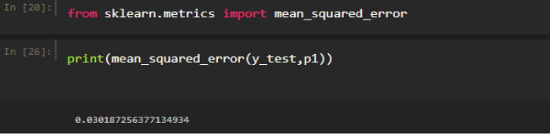
3. | Fine Tuning Result | Parameters: n_estimators=10, max_depth=5  Validation Accuracy ($R^2$): 0.92  Result: Successfully optimized to prevent overfitting while maintaining high precision. | 